30.
Comparison of the Systems
The three systems should be evaluated using accuracy, latency, and cost together rather than accuracy alone.
Model | Accuracy | Latency | Cost | Overall Evaluation
A | 88% | 50 ms | Low | Fast and economical, but lowest accuracy
B | 92% | 80 ms | Moderate | Good balance of accuracy, speed, and cost
C | 95% | 120 ms | High | Highest accuracy, but slowest and most expensive
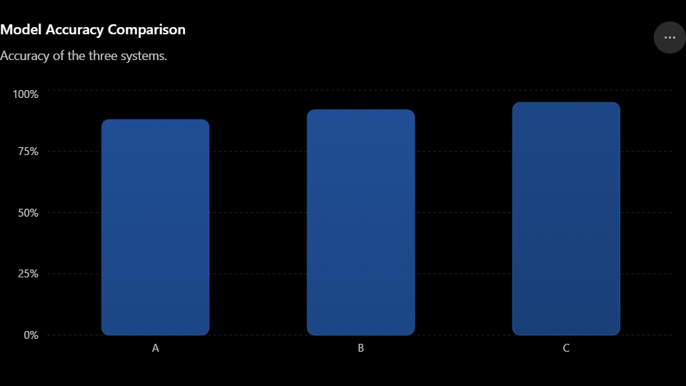

Evaluation
Model A:
Model A has the lowest accuracy of 88%, but it provides the lowest latency of 50 ms and has a low cost. It is suitable for applications where fast response and low computational cost are more important than maximum accuracy.
Model B:
Model B achieves 92% accuracy with only 80 ms latency and moderate cost. It improves accuracy by 4 percentage points over Model A while remaining reasonably fast and affordable. Therefore, it provides the best compromise between the three constraints.
Model C:
Model C gives the highest accuracy of 95%, but its latency is 120 ms, which is more than twice that of Model A, and its cost is high. It is appropriate when accuracy is the most critical requirement and higher latency and cost are acceptable.
Best Choice
Model B is the best overall system when all constraints are considered.
Although Model C has the highest accuracy, the improvement from 92% to 95% is only 3 percentage points, while latency increases from 80 ms to 120 ms and cost increases from moderate to high. Model A is cheaper and faster, but its 88% accuracy may be insufficient for applications requiring reliable results.
Therefore, Model B offers the best trade-off between accuracy, latency, and cost. It is particularly suitable for real-time applications where good accuracy is required without excessive computational cost or delay.
Conclusion:
- Accuracy priority → Model C
- Speed and low cost priority → Model A
- Balanced overall performance → Model B (recommended)

18.
Comparison and Evaluation of the Best System
The models should not be compared only based on training accuracy. For deployment, testing accuracy, generalization, robustness, and computational requirements must be considered.
Model | Training Accuracy | Testing Accuracy | Generalization Gap | Evaluation
A | 97% | 75% | 22% | High training performance but poor generalization
B | 90% | 88% | 2% | Strong generalization and reliable performance
Model A
Model A achieves a very high 97% training accuracy, which initially appears impressive. However, its testing accuracy falls to only 75%. The difference between training and testing accuracy is 22 percentage points.
This large gap indicates that Model A is likely overfitting the training data. In a real-world application, its performance may decrease considerably when it encounters new or unseen data. Therefore, despite its excellent training result, Model A is less robust and less reliable for deployment.
Model B
Model B achieves 90% training accuracy and 88% testing accuracy. The difference is only 2 percentage points, which indicates that the model performs consistently on both training and unseen testing data.
This small gap demonstrates better generalization and robustness. Although its training accuracy is lower than Model A's, its testing accuracy is significantly higher. For deployment, this consistency is more important because real-world data is usually different from the training data.
Overall Evaluation
The most important factors for deployment are:
- Testing accuracy: Model B achieves 88%, compared with 75% for Model A.
- Generalization: Model B has only a 2% gap, while Model A has a 22% gap.
- Robustness: Model B is more likely to maintain its performance on unseen data.
- Reliability: Model B's consistent training and testing performance makes it more dependable in practical applications.
- Computational constraints: No computational cost or latency data is provided, so these factors cannot be used to favor either model. If both have similar computational requirements, Model B is clearly preferable.
Final Decision
Model B is the best system for deployment.
Even though Model A has the higher training accuracy (97%), its poor testing accuracy (75%) and large generalization gap indicate overfitting. Model B achieves a better testing accuracy (88%) with only a 2% training-testing difference, making it more robust and reliable.
Therefore, Model B should be selected for real-world deployment because it provides the best balance of accuracy, generalization, and robustness on unseen data.

16.
Object Detection Under Scale Variation
Object Detection Accuracy by Object Size
Detection accuracy decreases significantly as object size becomes smaller.

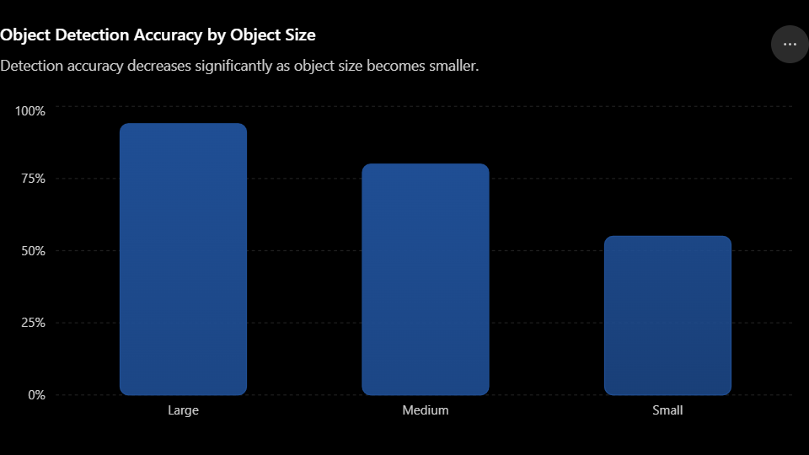
Comparison of Detection Performance
Object Size | Accuracy | Evaluation
Large | 94% | Excellent detection performance
Medium | 80% | Good but some objects are missed
Small | 55% | Poor detection performance
Analysis
The system performs very well for large objects, achieving 94% accuracy. This indicates that the detector can extract sufficient features when objects occupy a large portion of the image.
For medium-sized objects, accuracy decreases to 80%. Although the performance is still acceptable, some important features become less distinct because fewer pixels represent the object.
The major limitation occurs with small objects, where accuracy drops to only 55%. This represents a 39-percentage-point decrease compared with large objects. Small objects contain fewer pixels and therefore have less visual information available for feature extraction and classification.
System Limitations
- Poor small-object detection: The 55% accuracy indicates that nearly half of small-object cases may be incorrectly detected or missed.
- Scale sensitivity: Performance changes considerably with object size, showing that the system is not sufficiently scale-invariant.
- Loss of fine details: Downsampling and feature extraction can remove important features of small objects.
- Background interference: Small objects occupy fewer pixels, making them harder to distinguish from complex backgrounds.
- Detection-resolution limitation: A detector operating mainly at lower-resolution feature maps may lose information about very small objects.
Suggested Improvements
- Multi-scale feature extraction: Use Feature Pyramid Networks (FPN) or similar architectures to detect objects at different scales.
- Higher input resolution: Increasing image resolution can preserve more information about small objects.
- Data augmentation: Include resized, cropped, and scale-varied training images so the model learns different object sizes.
- Small-object detection layers: Add high-resolution detection layers specifically designed for small objects.
- Better feature fusion: Combine shallow high-resolution features with deeper semantic features.
- Appropriate anchor boxes: If an anchor-based detector is used, include smaller anchor sizes.
- Training with more small-object examples: A balanced dataset can improve the model's ability to recognize small targets.
Overall Evaluation
The system is effective for large objects (94%) and reasonably effective for medium objects (80%), but it has a significant weakness in detecting small objects (55%). Therefore, the system cannot be considered fully robust for applications where objects may appear at widely varying scales.
Best decision: Improve the detector using multi-scale feature extraction, higher-resolution processing, and scale-based data augmentation. These changes would make the system more robust and suitable for real-world applications such as surveillance, autonomous vehicles, and aerial image analysis, where small objects are often important.

20. Surveillance Model Selection – Evaluation Under Strict Latency Constraints
Given Results
Model | Accuracy | Latency | Evaluation
A | 82% | 30 ms | Fastest, but lowest accuracy
B | 90% | 70 ms | Good balance between accuracy and latency
C | 95% | 120 ms | Highest accuracy, but highest latency
Comparison
Model A:
Model A has the lowest latency of 30 ms, making it suitable for applications requiring very fast responses. However, its accuracy is only 82%, which may result in more missed or incorrectly detected events. It is suitable when real-time responsiveness is more important than detection accuracy.
Model B:
Model B provides 90% accuracy with 70 ms latency. It offers a strong compromise between detection performance and response time. Compared with Model A, it improves accuracy by 8 percentage points while adding only 40 ms of latency.
Model C:
Model C achieves the highest accuracy of 95%, but its latency is 120 ms. Although it provides the best detection accuracy, the high delay can be problematic for real-time surveillance, particularly when immediate detection and response are required.
Evaluation Under Strict Latency Constraints
If the surveillance system has a strict latency requirement of 100 ms, Model C should be rejected because its latency is 120 ms.
Between Models A and B:
- Model A: 82% accuracy, 30 ms latency
- Model B: 90% accuracy, 70 ms latency
Model B is generally the better choice because it remains below the 100 ms limit while providing substantially better accuracy.
Best System: Model B
Model B is the best overall choice under a strict 100 ms latency constraint.
It provides a good balance between:
- Accuracy: 90%
- Latency: 70 ms
- Real-time responsiveness: Acceptable
- Detection reliability: Better than Model A
- Computational requirement: Lower than Model C
Although Model A is faster, its lower accuracy can reduce surveillance reliability. Model C is more accurate but violates the assumed strict latency constraint.
Final Justification
For a real-time surveillance application, the highest accuracy alone should not determine model selection. The system must respond quickly enough to detect and react to events. Therefore, Model B is the most suitable system, as it achieves high accuracy while maintaining acceptable latency.
Conclusion:
Model B should be selected because it provides the best trade-off between accuracy and computational/latency constraints. Model A is preferred only when extremely low latency is the primary requirement, while Model C is suitable when accuracy is more important than real-time response.

21. Noise Impact on Detection
Given Results
Noise Level | Accuracy | Performance Evaluation
Low | 92% | Excellent
Medium | 80% | Good, but noticeable degradation
High | 60% | Poor
Detection Accuracy Under Different Noise Levels
Detection accuracy decreases as noise increases, indicating reduced robustne
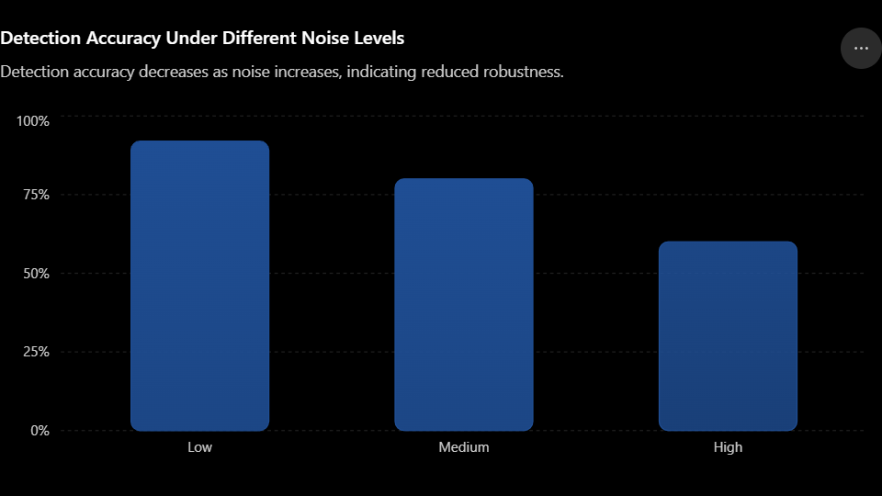
Performance Comparison
Low noise:
The system achieves 92% accuracy, showing that it performs very well under clean or slightly disturbed conditions.
Medium noise:
Accuracy decreases to 80%, representing a 12-percentage-point reduction from the low-noise condition. The system is still usable, but noise begins to affect feature extraction and object classification.
High noise:
Accuracy falls sharply to 60%, which is 32 percentage points lower than the low-noise result. This indicates that the system is highly sensitive to noisy environments.
Robustness Evaluation
The system has good robustness at low and medium noise levels, but poor robustness at high noise levels. The large accuracy drop shows that the detector cannot reliably maintain its performance when image quality deteriorates.
The major limitation is therefore noise sensitivity. In real-world surveillance, poor lighting, weather, camera interference, motion, compression, and environmental disturbances can introduce noise and reduce detection reliability.
Evaluation Under Strict Latency Constraints
The question provides accuracy under different noise levels but does not provide latency values. Therefore, a strict latency-based comparison cannot be numerically established from the given data.
If the system must also satisfy a strict latency requirement, improvements should avoid computationally expensive preprocessing that causes excessive delay. A practical solution would be to use lightweight real-time denoising before detection.
Recommended Improvements
- Noise reduction: Apply lightweight Gaussian, median, or adaptive filtering where appropriate.
- Data augmentation: Train the detector using images containing different levels and types of noise.
- Robust feature extraction: Use features that are less sensitive to image degradation.
- Multi-scale processing: Improve detection when noise affects objects of different sizes.
- Adaptive preprocessing: Apply stronger denoising only when the noise level is high to avoid unnecessary computation.
- Real-time optimization: Use lightweight models or hardware acceleration to maintain low latency.
- Robust training: Include realistic surveillance conditions such as low illumination, compression artifacts, and environmental noise.
Best System Evaluation
Since there is only one system being evaluated under different noise conditions, the objective is to make the system robust across all conditions rather than select between different models.
Criterion | Evaluation
Accuracy in low noise | Excellent – 92%
Accuracy in medium noise | Good – 80%
Accuracy in high noise | Poor – 60%
Noise robustness | Moderate to weak
Real-time suitability | Cannot be determined without latency data
Main limitation | Significant accuracy degradation at high noise
Final Conclusion
The system performs well in clean conditions but lacks sufficient robustness under high noise. 92% → 80% → 60% accuracy demonstrates a substantial degradation as noise increases.
For a real-time surveillance application, the best approach is to improve noise robustness using lightweight denoising and noise-aware data augmentation while maintaining low computational cost and latency.
Overall judgment: The current system is effective in low-noise environments but not sufficiently robust for highly noisy real-world surveillance conditions. A lightweight, adaptive preprocessing and training strategy would provide the best balance between accuracy, robustness, and computational/latency constraints.
4. Background Modeling Strategy – GMM
Introduction
A Gaussian Mixture Model (GMM) is commonly used for background subtraction in video surveillance. It models the background using multiple Gaussian distributions and identifies pixels that differ significantly from the learned background as foreground objects.
The given results show two important problems:
- Dynamic background → High false positives
- Static background → Missed detections
Therefore, GMM performance is not equally reliable across different environmental conditions.
Comparison Across Scenarios
Scenario | Observed Performance | Problem | Robustness
Dynamic background | Poor | High false positives | Low
Static background | Poor in given case | Missed detections | Low
Normal/controlled background | Generally better | Fewer disturbances | Moderate
1. Dynamic Background
In a dynamic environment, objects such as moving trees, waving curtains, water, shadows, or changing illumination continuously change pixel values.
GMM may interpret these legitimate background movements as foreground objects. This produces a high number of false positives.
For example, a moving tree branch may be incorrectly classified as a moving person.
Evaluation:
GMM has limited robustness against continuously changing backgrounds unless its parameters are adapted appropriately.
2. Static Background
A static background should normally be easier for GMM. However, the given result reports missed detections.
This can occur when the model adapts too strongly to the scene and gradually incorporates a stationary or slowly moving object into the background. Consequently, an actual foreground object may no longer be detected.
Evaluation:
This indicates that GMM has a trade-off between adaptation and detection sensitivity.
Is GMM Alone Sufficient?
No. GMM alone is not sufficient for a robust surveillance system.
Although GMM is computationally practical and can work well in controlled environments, its performance can deteriorate when:
- the background contains continuous motion,
- illumination changes,
- shadows are present,
- objects stop moving,
- objects move slowly,
- the scene changes significantly.
Thus, relying only on GMM can result in both false positives and false negatives.
Improvements
1. Adaptive GMM
Instead of using fixed parameters, continuously update the Gaussian distributions according to changes in the environment.
Benefit: Better handling of gradual background changes.
2. Shadow Removal
Add a shadow-detection and removal step after background subtraction.
Benefit: Prevents shadows from being incorrectly classified as foreground objects.
3. Morphological Filtering
Use operations such as opening, closing, erosion, and dilation to remove small noise and fill gaps in detected objects.
Benefit: Produces cleaner foreground masks and reduces false detections.
4. Combine GMM with Object Detection
A stronger system can use GMM for fast motion detection and a lightweight object detector for verification.
Benefit: GMM provides fast candidate regions while the detector confirms whether the region actually contains a relevant object.
5. Adaptive Learning Rate
The learning rate should change according to scene conditions.
- Faster adaptation → useful when the background changes.
- Slower adaptation → prevents stationary foreground objects from being absorbed too quickly.
Strict Latency Consideration
For real-time surveillance, accuracy cannot be considered independently of latency.
Approach | Accuracy/Robustness | Computational Cost | Latency
GMM alone | Moderate | Low | Very low
GMM + morphological filtering | Better | Low | Low
GMM + shadow removal | Better | Moderate | Moderate
GMM + heavy deep-learning detector | High potential | High | High
Adaptive GMM + lightweight verification | High potential | Moderate | Suitable for real-time
A deep-learning detector may provide better recognition, but using a large model for every video frame can introduce unacceptable latency. Therefore, it is not necessarily the best solution when strict real-time constraints exist.
Best Overall Strategy
The best approach is Adaptive GMM + lightweight post-processing + selective object verification.
A suitable pipeline is:
Video → Adaptive GMM → Morphological Filtering → Shadow Removal → Candidate Objects → Lightweight Object Verification → Final Detection
This approach combines the low computational cost of GMM with additional techniques that address its weaknesses.
Overall Evaluation
Factor | GMM Alone | Improved GMM
Dynamic-background robustness | Poor | Better
Static-object detection | Poor in given case | Better
False positives | High in dynamic scenes | Reduced
False negatives | Possible | Reduced
Computational cost | Low | Low–moderate
Latency | Very low | Low–moderate
Real-time suitability | Good | Very good
Overall robustness | Moderate/low | High potential
Conclusion
GMM alone is not sufficient for a reliable surveillance system because it produces false positives in dynamic backgrounds and missed detections in static-background situations.
The best solution is to retain GMM because of its low computational cost and low latency, while improving it with adaptive learning rates, shadow removal, morphological filtering, and lightweight object verification.
Final judgment: For strict real-time surveillance, Adaptive GMM with lightweight post-processing and selective verification provides the best balance of accuracy, robustness, computational efficiency, and latency. It is preferable to either using basic GMM alone or replacing the entire system with a computationally expensive deep-learning detector.
29. Detection Under Occlusion
Given Results
Method | Accuracy | Robustness under Occlusion | Evaluation
A | 70% | Low | Weak performance
B | 85% | Good | Strong performance
C | 90% | Very good | Best accuracy
Performance Comparison
Detection Accuracy Under Occlusion
Method C achieves the highest detection accuracy, followed by B and A.
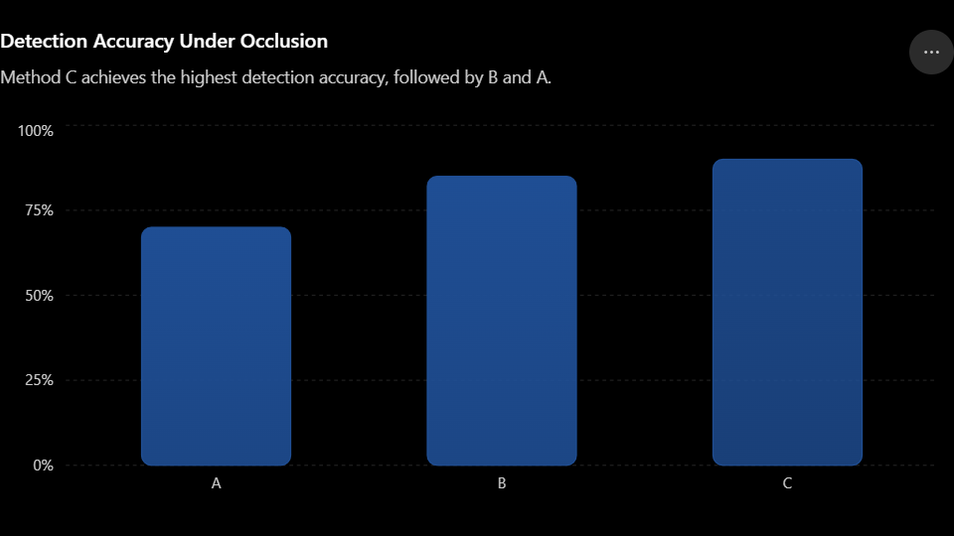
Method A
Method A achieves only 70% accuracy, indicating that it struggles considerably when objects are partially hidden.
Its relatively low accuracy suggests that it depends heavily on complete visual information. When important portions of an object are blocked, the method may fail to extract sufficient features.
Evaluation: Low robustness under occlusion.
Method B
Method B achieves 85% accuracy, which is significantly better than Method A.
The improvement of 15 percentage points indicates that Method B can handle partial object visibility more effectively. It is a strong alternative when a balance between detection quality and computational requirements is needed.
Evaluation: Good robustness.
Method C
Method C achieves the highest accuracy of 90%. It outperforms Method A by 20 percentage points and Method B by 5 percentage points.
This suggests that Method C is the most capable of recovering useful information when objects are partially occluded.
Evaluation: Best robustness based on the available accuracy results.

Comparison Under Strict Latency Constraints
The question provides accuracy but no latency values. Therefore, it is not possible to prove which method is best under a specific strict latency limit.
If all three methods have acceptable latency, Method C should be selected because it provides the highest accuracy and therefore the best demonstrated robustness.
However, if Method C has substantially higher computational cost or latency, Method B may be the better practical choice, provided it satisfies the application's latency requirement.
Factor | A | B | C
Accuracy | 70% | 85% | 90%
Occlusion robustness | Low | Good | Very good
Expected computational demand* | Low | Moderate | Potentially higher
Real-time suitability* | High | High/Moderate | Depends on latency
Overall detection performance | Weak | Strong | Best
*Computational cost and latency are not given in the question, so they cannot be quantitatively compared.
Best System Considering All Constraints
Method C is the best based on the given evidence because it achieves 90% accuracy, the highest among all methods, making it the most robust against occlusion.
However, for a strict real-time surveillance system, the final choice should depend on measured latency:
- If C meets the latency limit → choose C.
- If C violates the latency limit → choose B, provided B satisfies the latency requirement.
- Choose A only when extremely low computational cost/latency is more important than detection accuracy.
Suggested Improvements
To further improve occlusion robustness:
- Use partial-object features so the system can recognize objects even when only part is visible.
- Temporal information can be used to track an object before and after occlusion.
- Multi-object tracking can maintain object identity during temporary occlusion.
- Data augmentation with artificial occlusion can train the model to handle blocked objects.
- Feature fusion can combine local and global features.
- Lightweight models can be used if strict latency is important.
Final Conclusion
Method C is the best-performing method, with 90% accuracy, followed by Method B at 85% and Method A at 70%. Therefore, C demonstrates the strongest robustness to occlusion.
Final judgment: Select Method C if it satisfies the application's latency and computational constraints. If strict latency makes C impractical, Method B is the best compromise, offering substantially better robustness than A while potentially requiring fewer computational resources than C.
15. GMM Performance in Different Conditions
Given Results
Scenario | Accuracy | Performance Evaluation
Static | 92% | Excellent
Dynamic | 68% | Poor to moderate
GMM Accuracy in Different Environments
GMM performs substantially better in static backgrounds than in dynamic backgrounds
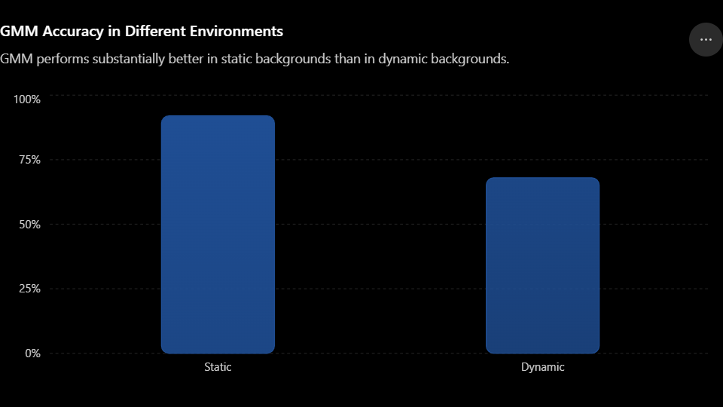
Performance Comparison
Static Environment – 92%:
GMM performs very well when the background remains relatively unchanged. Since background pixels are stable, the Gaussian distributions can model them effectively, allowing moving objects to be separated accurately.
Dynamic Environment – 68%:
Performance drops significantly in a dynamic environment. The accuracy decreases by 24 percentage points compared with the static condition. Moving trees, waving objects, changing illumination, shadows, and other background motion can be incorrectly classified as foreground.
Robustness Evaluation
The results indicate that GMM has good performance in static environments but weak robustness across changing environments.
The large accuracy difference demonstrates that GMM is not fully environment-independent. A surveillance system deployed outdoors or in locations with continuously changing backgrounds may therefore experience increased false positives and missed detections.
Is GMM Reliable for All Environments?
No. GMM alone cannot be considered reliable for all environments.
It is particularly suitable for:
- Indoor surveillance
- Fixed cameras
- Relatively stable backgrounds
- Controlled lighting conditions
It is less reliable for:
- Outdoor surveillance
- Dynamic backgrounds
- Moving vegetation
- Changing illumination
- Crowded or highly active scenes
Improvements
- Adaptive GMM: Dynamically update the Gaussian distributions according to background changes.
- Adaptive learning rate: Use faster adaptation for rapidly changing backgrounds and slower adaptation for stable scenes.
- Shadow removal: Prevent shadows from being incorrectly detected as foreground.
- Morphological filtering: Remove small noisy regions and improve the detected foreground mask.
- Noise reduction: Apply lightweight preprocessing before background subtraction.
- Multi-model background subtraction: Combine GMM with another background-modeling technique to improve robustness.
- Object verification: Use a lightweight detector to verify important foreground regions.
Strict Latency Constraints
The question provides accuracy but no latency measurements, so a numerical latency comparison cannot be made.
However, GMM has an important advantage: it is generally computationally lighter than large deep-learning detection models. Therefore, it can be a good choice for real-time surveillance when low latency is important.
A practical improvement would be:
Video → Adaptive GMM → Morphological Filtering → Shadow Removal → Lightweight Object Verification
This avoids running an expensive detector on every pixel or every frame while improving GMM's weaknesses.
Best Overall Evaluation
Factor | Static Environment | Dynamic Environment
Accuracy | 92% | 68%
Background stability | High | Low
GMM robustness | Good | Poor/moderate
False-positive risk | Low | Higher
Computational efficiency | High | High, but accuracy suffers
Real-time potential | Excellent | Good with improvements
Final Conclusion
GMM achieves 92% accuracy in static environments, demonstrating that it is highly effective when the background is stable. However, accuracy falls to 68% in dynamic environments, showing a significant loss of robustness.
Therefore, GMM alone should not be considered reliable for all environments.
Best solution: Use an adaptive GMM with lightweight shadow removal, morphological filtering, and selective object verification. This provides a better balance of accuracy, robustness, computational efficiency, and low latency than using basic GMM alone or replacing it entirely with a computationally expensive model.
Final judgment: GMM is a good low-latency background-subtraction method, but it needs adaptive improvements to become reliable for diverse real-world surveillance environments.

